**International Institute of Professional Studies**

**DAVV (Indore)**

**MCA (6 yrs) VI Semester**



**2019-20**

Minor Project Report on

“***Quizza***”

**Student’s test System**

A Dissertation submitted to

IIPS-DAVV, Indore

**Submitted To: - Submitted By: -**

**Dr. Kirti Mathur**  **Prasuk Jain (IC-2K17-28)**

**Yash Joshi (IC-2K17-46)**

**Yashdeep Shah (IC-2K17-47)**

**Declaration**

I hereby declare that the project entitled **“*Quizza*” (STUDENT’s TEST SYSTEM)** submitted by **Prasuk Jain, Yash Joshi & Yashdeep Shah,** for the partial fulfillment of the requirement for the award of Master of Computer Application (6 Years) IV Semester to International Institute of Professional Studies, Devi Ahilya Vishwavidyalaya, Indore, comprises our work and due acknowledgement has been made in text to all other material used.

**Signature of Students:__________ Dr. Kirti Mathur**

**__________ Project Incharge**

**__________**

**Date:**

**Certificate**

It is to certify that we have examined the dissertation on “**Quizza**” **(Student’s Test System)**, submitted by **Prasuk Jain (IC-2K17-28), Yash Joshi (IC-2K17-46), Yashdeep Shah (IC-2K17-47)** to the International Institute of Professional Studies, DAVV, Indore and hereby accord our approval of it as a study carried out and presented in a manner required for its acceptance in partial fulfillment for the award of the degree of “Master of Computer Application (6 Years) IV Semester”.

Internal Examiner External Examiner

Signature: Signature:

Name : Name :

Date : Date :

**Acknowledgement**

# *“To make efforts is better than to achieve success and to choose the*

***Capable person for success is greater than to make efforts and Succeed”***

We gratefully acknowledge the valuable guidance, intelligent suggestions, fruitful discussion and generous encouragement of **Dr. Kirti Mathur Project Incharge, Masters of computer application (6-yrs)** for successful completion of this Minor Project Report. Without his help it would have been difficult to overcome the conceptual and practical problems.

We are ever grateful to **Dr. A.K. Sapre, Director, IIPS DAVV, Indore** for providing all facilities and academic environment of my work.

Finally We are thankful to **Dr. A.K. Sapre, Director of IIPS DAVV**, **Dr. Kirti Mathur (Project Incharge)** and **all the faculties of** International Institute of Professional Studies, Indore for their institutional support.

I am also thankful to all others who have directly or indirectly helped us to carry out this work.

**Prasuk Jain (IC-2K17-28)**

**Yash Joshi (IC-2K17-46)**

**Yashdeep Shah (IC-2K17-47)**

MCA-6years (VI Semester)

IIPS, Indore

**Abstract**

Every day, teachers make countless real-time decisions and facilitate dozens of interactions between themselves and their students. An active interaction between teachers and students would lead to an efficient teaching and learning to take place. The teacher-student relationships impact productively on a student’s self-esteem and enhance their skills. Student-Teacher interactions are very important for the development of the students’ academic self-concept and enhancing their enthusiasm and success. Colleges and universities that actively promote close and frequent contact between their students and faculty members are more likely to reap a host of benefits from such initiatives, but it has been seen that these interactions are usually limited to classrooms and not outside them and to terminate this drawback of class room teaching, We’ve come up with the idea of Student Teacher educational portal which would help increase an active interaction between students and teachers outside the classroom. Our software has multiple features that would support an active interaction outside the classroom as well it would support the classroom system itself. We have a Test System where the teachers can create a test and start or stop it whenever they want and check the scores of the students afterwards too. Along with this software also includes a chat system, individual chat and group chat according to the subjects.

**Table of Contents**

**• Recommendation**

**• Dissertation Approval Sheet**

**• Certificate**

**• Acknowledgement**

**• Abstract**

**1 Introduction**

**1.1 Problem Definition**

**1.2 Aim**

**1.3 Objectives**

**1.4 Benefits**

**2 Project Planning**

**2.1 Gantt Chart**

**3 System Design**

**3.1 Logical Design**

**3.1.1 Entity Definition**

**3.1.2 Attribute Definition**

**3.1.3 E-R Diagram**

**3.1.4 Flow Chart**

**3.2 Physical Design with Code**

**3.2.1 User Interfaces**

**4 Implementation (Source Code)**

**5 System Requirements**

**6 Future Plans**

**7 Conclusion**

**8 Bibliography**

**9 Appendices**

**Introduction**

**Problem Definition**

**Our Project deals with the following problems in the following ways**

**Problem 1:** Teacher-Student Interaction Restricted to Classroom.

**Solution:** The chatgroup system would enable the teachers and students to communicate outside the classroom.

**Problem 2:** Pen and Paper tests and all of its disadvantages.

**Solution:** The traditional pen and paper system is going obsolete as everything is getting digitalised and why won’t it be obsolete? After all it wastes paper and a lot of time that teacher spends while distributing and collecting the answer sheets and question paper to students and that distribution and collection also goes on sequentially thus not being completely fair for the students as some might get extra time because of this fact. Even the checking of these tests are time consuming for teachers. The web portal provides an efficient system regarding this problem where teachers get to create tests and manage them like starting a test, stopping it and checking its result. The test would start on each students’ screen at the same time whenever the teacher starts it and auto submit after a time duration that is the same for every student, thus being fair. The teacher won’t even have to check the answers as it will automatically calculate the scores and produce a result.

**Problem 3:** What if Student want to practice already given test?

Solution: We provide practice based tests for students. So that they can analyze themselves afterwards. And see their results without teacher knowing.

**Aim**

• The main aim of the project is to act as a major supportive element in teaching by assisting and replacing some of the traditional methods used in a typical classroom environment.

• The supportive elements would be the chatroom system which would promote an active interaction of students and teacher outside the classroom.

• The replacements would be a practice test and ongoing test system.

**Objectives**

**To achieve the aim and to successfully get effective solutions for the problems the following objectives were there:**

• To create a working and an effective software.

• To maintain and store the data effectively in a database for the software.

• To only let the authorized users, utilize and operate on the features of the software.

• To make the UI effective and easy to understand for everyone.

• To make sure that nothing unwanted and explicit shows up on the system with a moderation system.

• To make features such that they would efficiently support the traditional non digitalized classroom environment and even replace any of the obsolete methods.

**Benefits**

The chatgroup system would enable the teachers and students to communicate outside the classroom via the software thus increasing the overall interaction of teachers and students even outside the classroom. We all know that the total strength of a class is never there except for some special cases, this might lead to an improper delivery of notices and announcements. We are eliminating this problem with our notice system on which the teachers can set up notice for students thus ensuring a proper delivery of notices. The notice system will ensure that the teachers can make any kind of notice containing whatever information they might want to convey. Teachers will have the power to moderate the posts by deleting the unwanted ones. The traditional pen and paper system are going obsolete as everything is getting digitalised and why won’t it be obsolete? After all it wastes paper and a lot of time that teacher spends while distributing and collecting the answer sheets and question paper to students and that distribution and collection also goes on sequentially thus not being completely fair for the students as some might get extra time because of this fact. Even the checking of these tests are time consuming for teachers. The software provides an efficient system regarding this problem where teachers get to create tests and manage them like starting a test, stopping it and checking its result. The test would start on each students’ screen whenever the students enter the given password for that test and auto submit after a time duration that is the same for every student, thus being fair. The teacher won’t even have to check the answers as it will automatically calculate the scores and produce a result. We also provide practice based tests, previous test, for the students to analyze themselves. Last but not least only the authorised users will be able to use the features of our Software.

**Project Planning**

**Gantt Chart**

**Assigned work:**

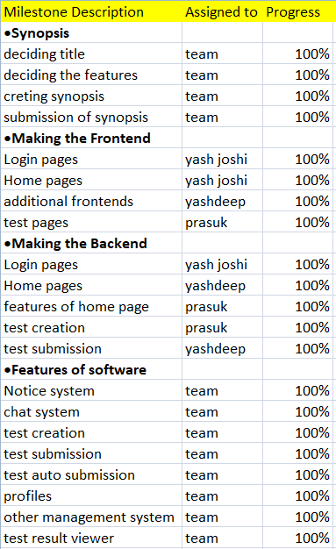

**System Design**

**1. Logical Design**

**a. Entity Definition**

i. Users (User system): This entity would contain the details of the users and would be used mainly by the login system and some other features.

ii. Test List (tlist): This entity contains the information of both ongoing and previous tests.

iii. Notice: This contains all the Notice created and the information about who and when they were created.

iv. Chat: This entity contains the messages and other details regarding them and it is used by the chat system. For both group and personal chats.

v. Dynamic Entities:

1. Tests: A new entity would be created each time a new test is created.

2. Test Result: It would be a supportive entity created each time with a new test and would store the results.

**b. Attribute Definition**

i. UserSystem:

1. username: int (10), primary_key

2. name: text

3. email: varchar (20)

4. password: varchar (10)

5. subject: varchar (20) [for teacher only]

6. DOB: date

7. number: varchar (11)

8. gender: varchar (6)

9. roll number: varchar (20) [for student only], primary key

ii. tlist:

1. tid: int (10), primary_key

2. tname: varchar (25)

3. password: varchar(10) [for ongoing tests]

4. tqnum: int (3)

iii. Notice:

1. N_id: int (10), primary key

2. N_name: varchar (25)

3. N_content: text

4. N_date: date

iv. Chat & Group Chat:

1. name: varchar (25)

2. content: mediumtext

3. time: datetime

viii. Dynamic Tables:

1. Testname:

a. Qno: int (11)

b. Qcontent: mediumtext

c. Qoption_a: mediumtext

d. Qoption_b: mediumtext

e. Qoption_c: mediumtext

f. Qoption_d: mediumtext

g. Qcorr_option: mediumtext

h. password : varchar (10) [for ongoing test]

2. Rtestname:

a. id: int (10)

b. roll_number: varchar (20)

c. Name: varchar (30)

d. Score: int (3)

**c. Entity Relationship Diagram**

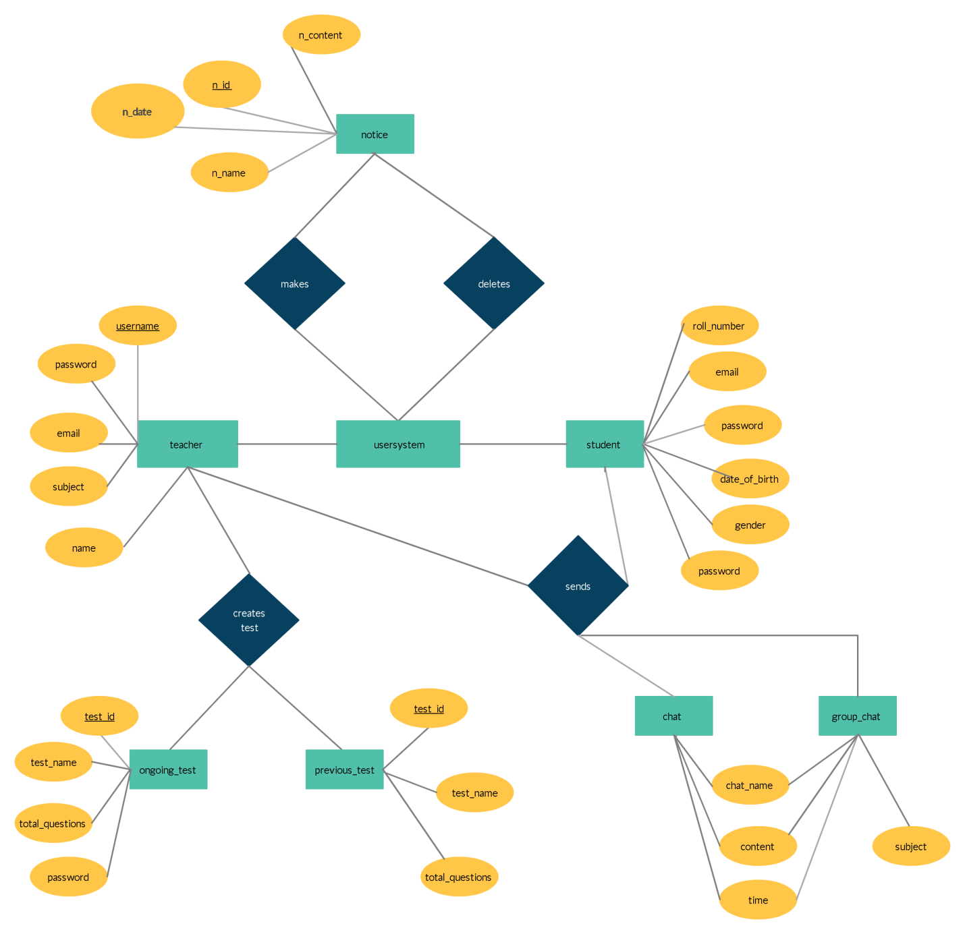

Figure: 1 (E-R Diagram)

**d. Flow Chart**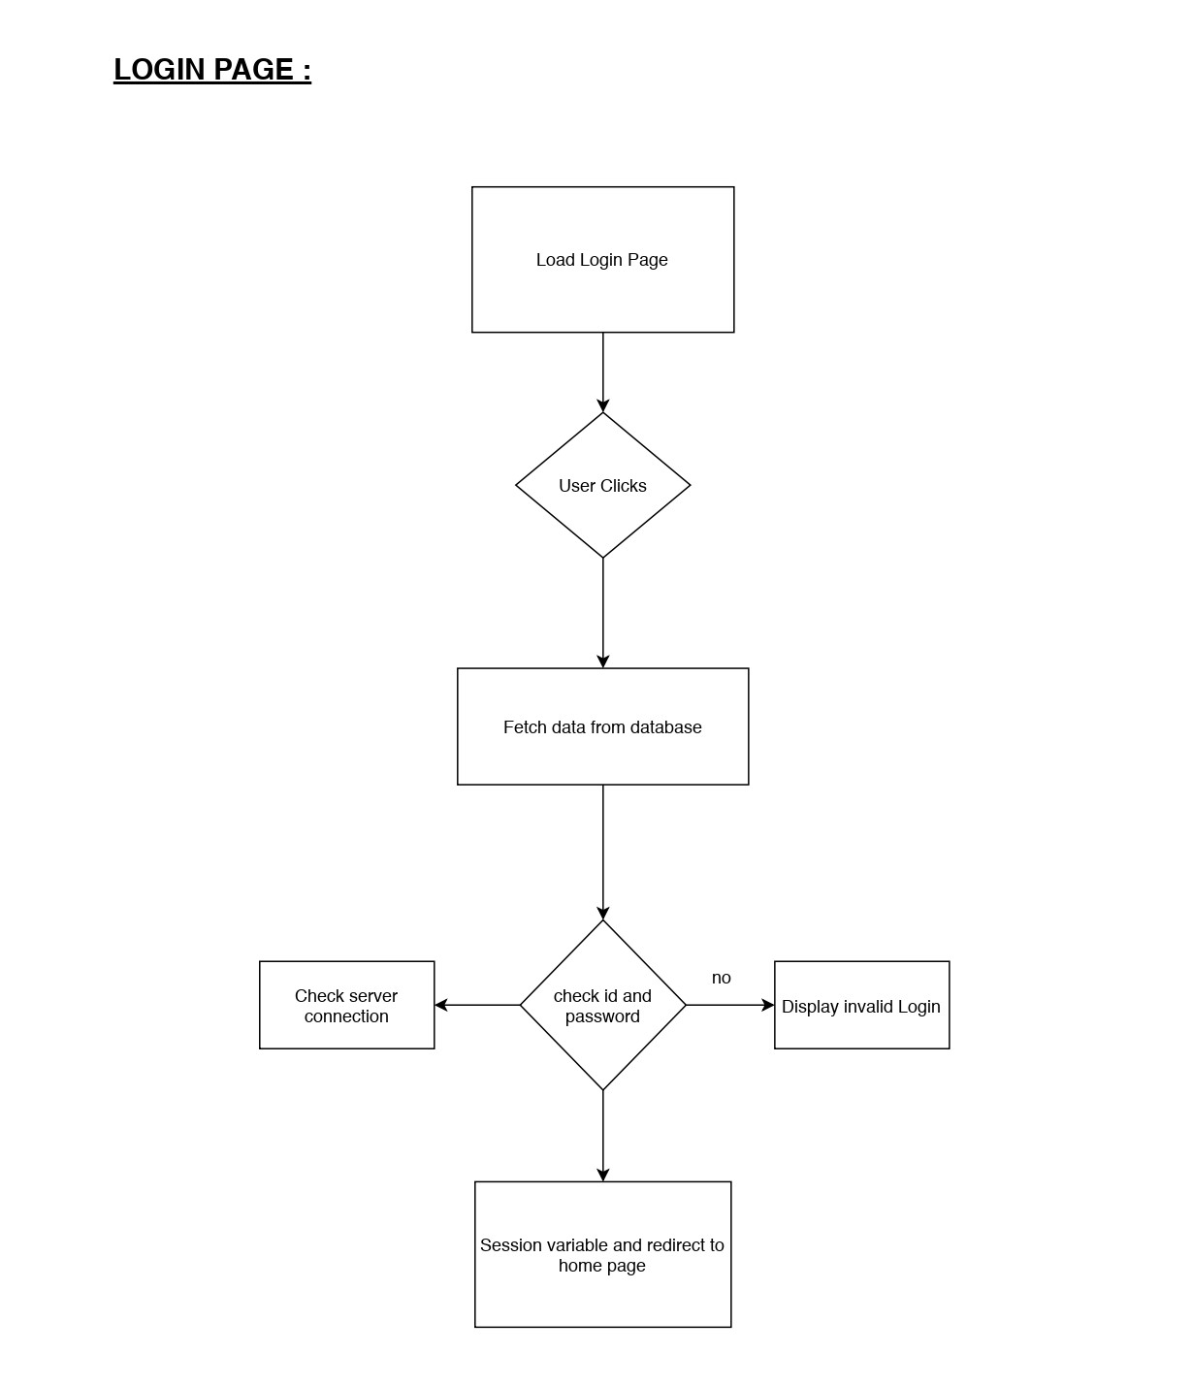

Figure: 2 (Flow-Chart for Login Page)

**HOME PAGE :**

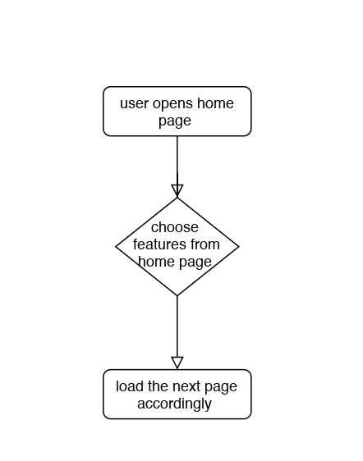

Figure: 3 (Flow-Chart for Home Page)

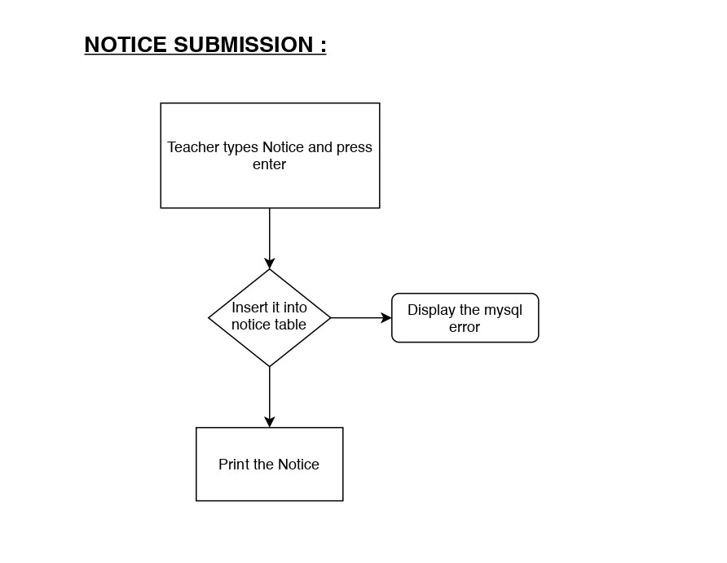

**Display Server Error**

Figure: 4 (Flow-Chart for Notice Submission)

**CHAT BOX :**

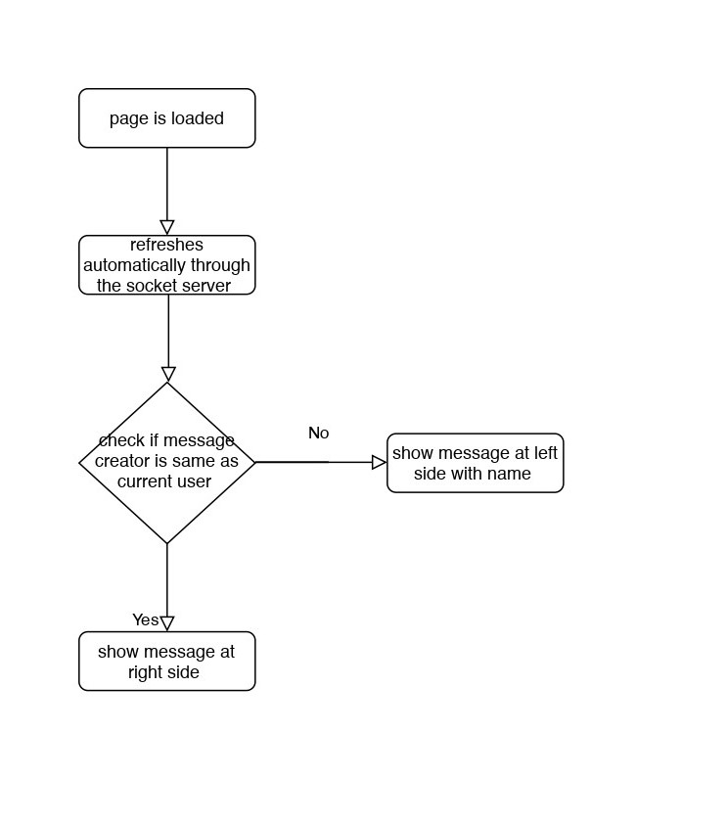

Figure: 5 (Flow-Chart for Chat Box)

**MESSAGE SENDING :**

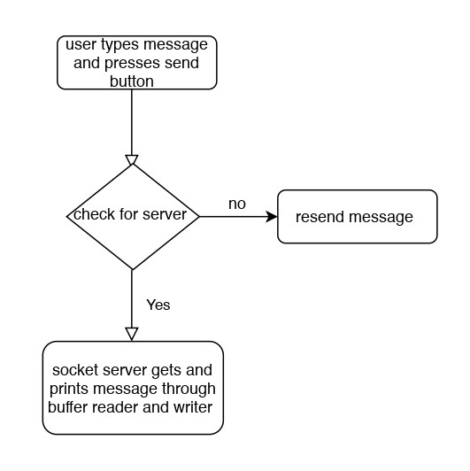

Figure: 6 (Flow-Chart for Sending Message)

**TEST SYSTEM :**

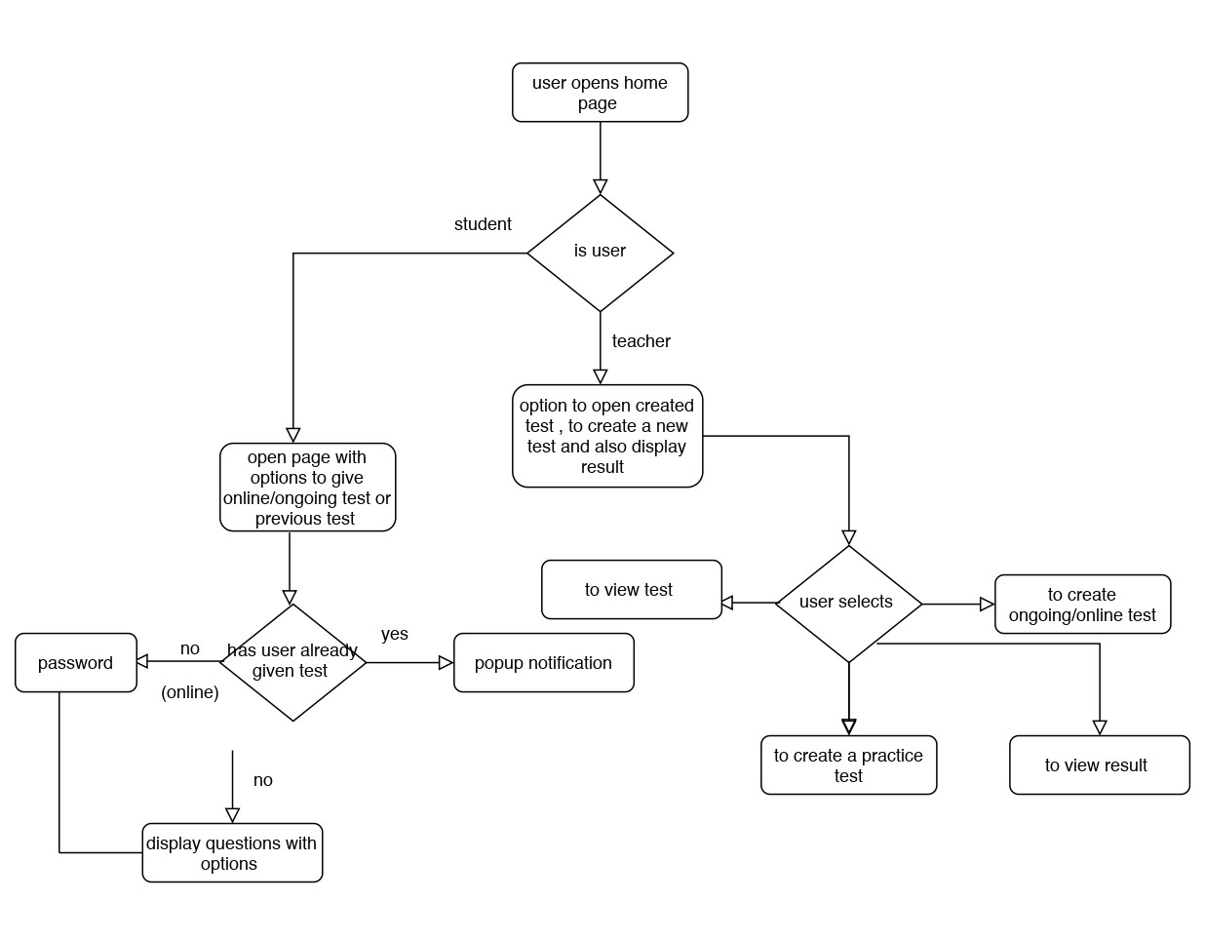

Figure: 7 (Flow-Chart for Test System)

**2. Physical Design with Code**

a. Splash Screen

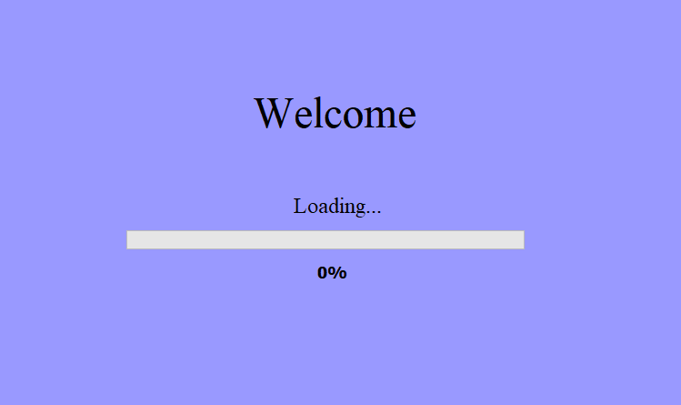

Splash sc = new Splash();

/* Create and display the form */

java.awt.EventQueue.invokeLater(new Runnable() {

public void run() {

sc.setVisible(true);}

});

try{

for(int i=0;i<=100;i++){

Thread.sleep(10);

sc.bar.setValue(i);

sc.progress.setText(i+"%");

} }

catch(Exception e) {

System.out.println(e);

}

sc.setVisible(false);

new StudentLogin().setVisible(true);

Server.main(null);

b. Login Pages

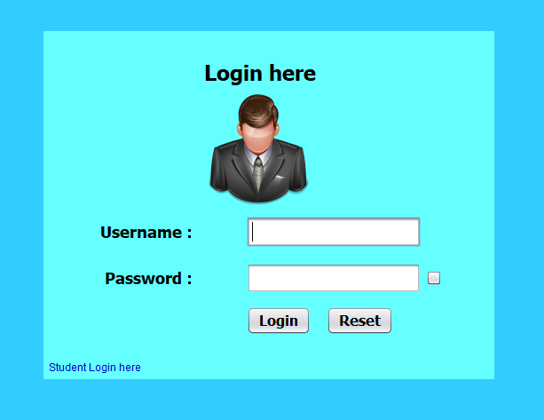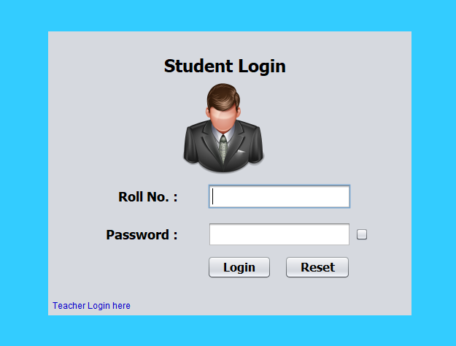

if(rollNo!=null && password!=null && !rollNo.trim().equals("") && password.equals(tablePassword))

{

new StudentHome(rollNo,this,name).setVisible(true);

this.setVisible(false);

upass.setText("");

}

else

{message.setVisible(true);

upass.setText("");

}

c. Home Pages

student home:

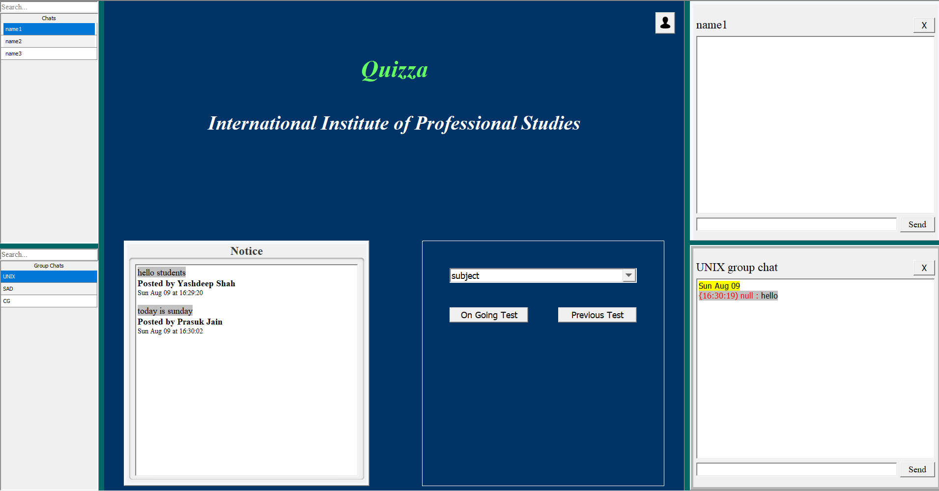

teacher home:

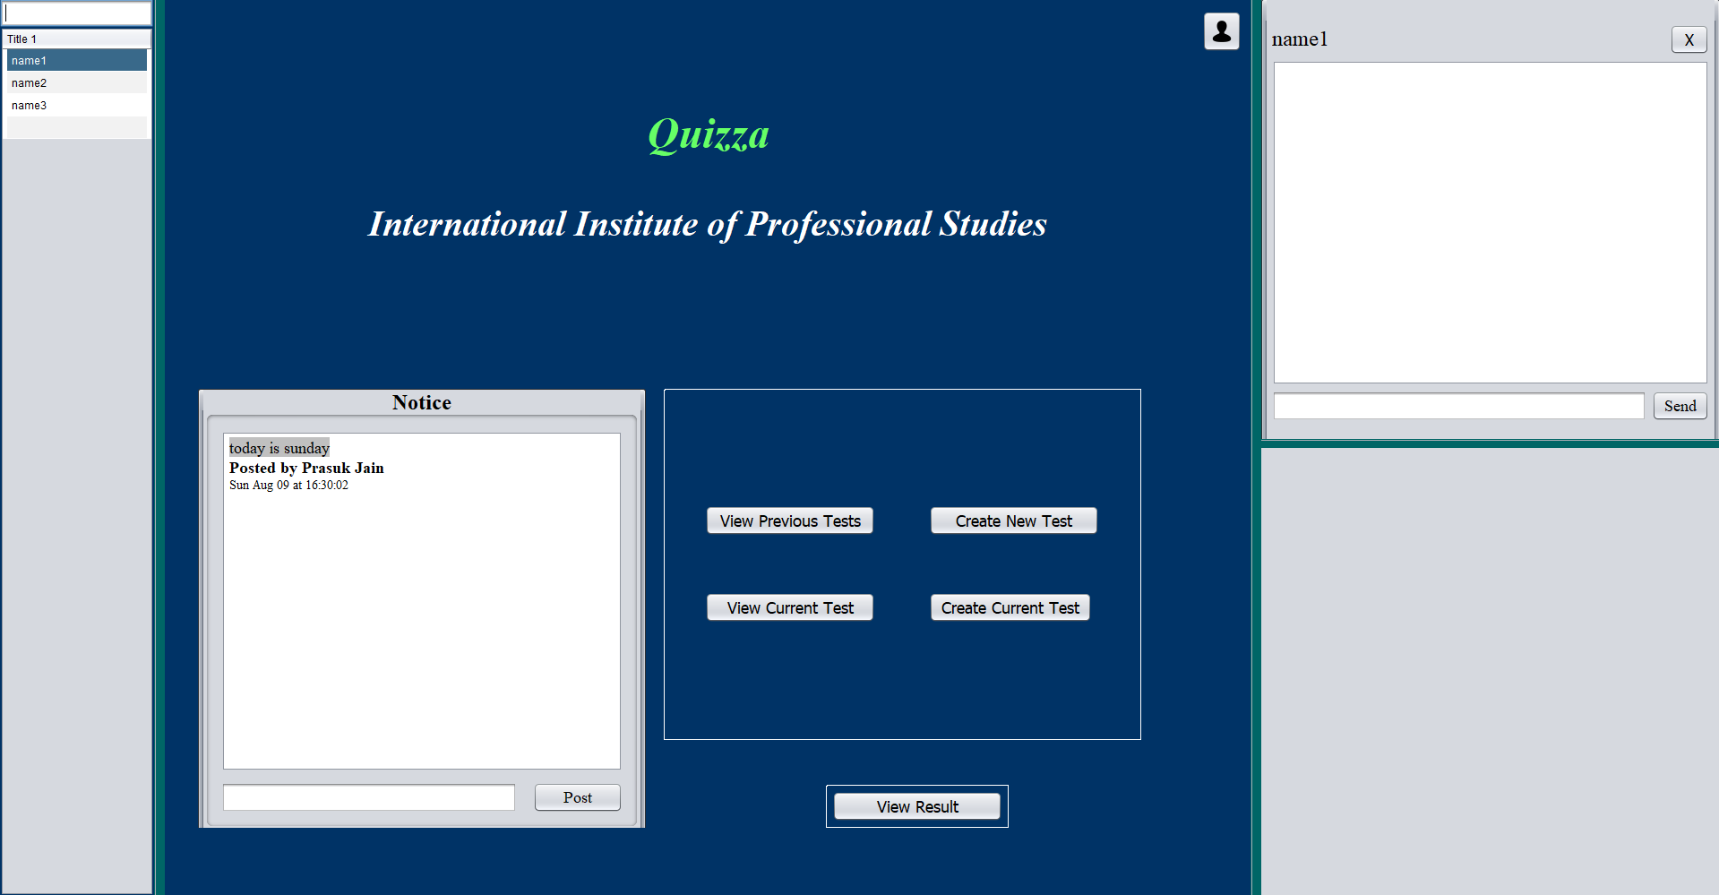

d. Teacher view previous test

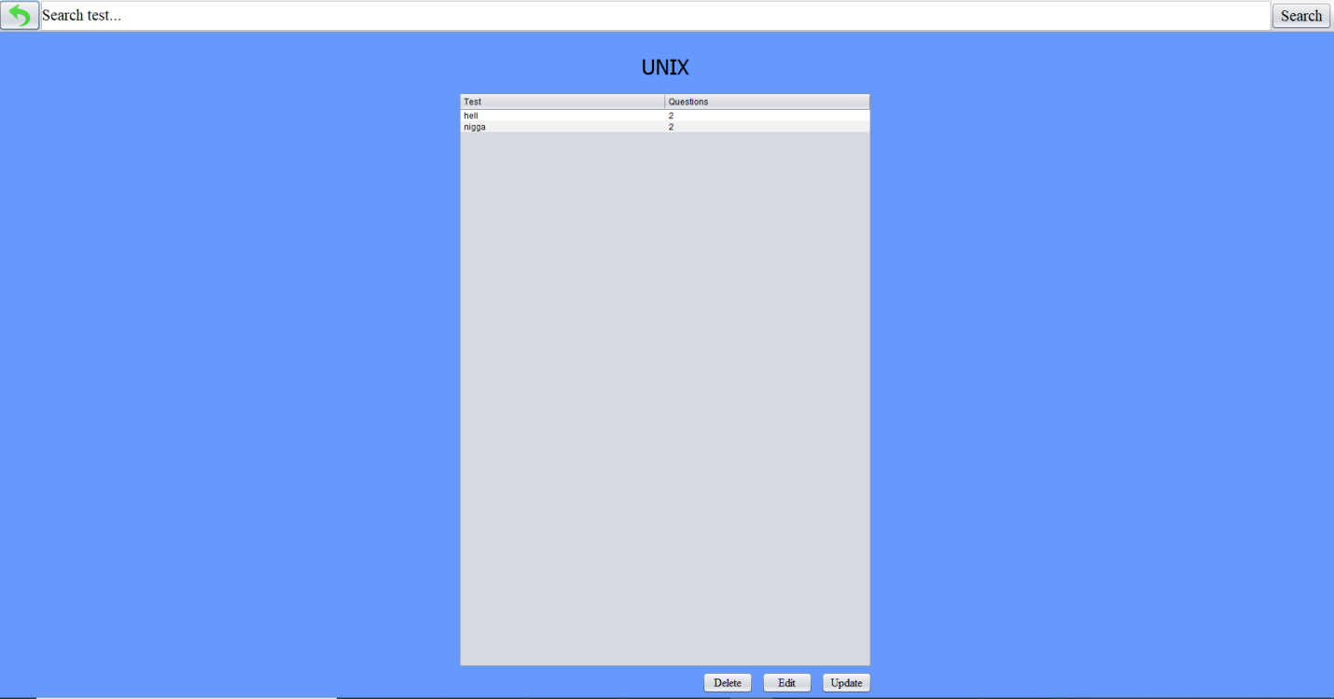

try{

Class.forName("com.mysql.jdbc.Driver");

con = DriverManager.getConnection("jdbc:mysql://localhost:3306/test","root","root");

st = con.createStatement();

query1 = "RENAME TABLE `"+subject+"`.`"+tab[r][0]+"` TO `"+value+"`";

query2 = "RENAME TABLE `studentresult`.`"+tab[r][0]+"` TO `"+value+"`";

if(online){

rs = st.executeQuery("SELECT password FROM `"+subject+"`.`online_test` WHERE `Test_Name`='"+tab[r][0]+"'");

if(rs.next())

testPass = rs.getString(1);

query = "UPDATE `"+subject+"`.`online_test` SET `Test_Name`='"+value+"',"+

"`Number_of_Questions`='"+table2.getModel().getValueAt(r, 1)+"',"+

" `password`='"+testPass+"' WHERE `Test_Name`='"+tab[r][0]+"'";

}

else{

query = "UPDATE `"+subject+"`.`test` SET `Test_Name`='"+value+"',"+

"`Number_of_Questions`='"+table2.getModel().getValueAt(r, 1)+"' WHERE `Test_Name`='"+tab[r][0]+"'";

}

st.execute(query1);

st.execute(query2);

st.executeUpdate(query);

tab[r][0] = value;

con.close();

}

catch (ClassNotFoundException e)

{

System.out.println(e);

}

catch(MySQLSyntaxErrorException e)

{

StringWriter sw = new StringWriter();

e.printStackTrace(new PrintWriter(sw));

String es = sw.toString();

JFrame f = new JFrame();

JOptionPane.showMessageDialog(f, es.substring(es.indexOf(':')+2, es.indexOf('\n')).replaceAll("Table", "Test"));

b=false;

table2.getModel().setValueAt(tab[r][0], r, 0);

}

catch(SQLException e)

{

JFrame f = new JFrame();

JOptionPane.showMessageDialog(f, "Could Not Update");

}

}

}

if(b)

{

new Home(username,subject).setVisible(true);

this.setVisible(false);

}

}

d. Teacher edit previous test

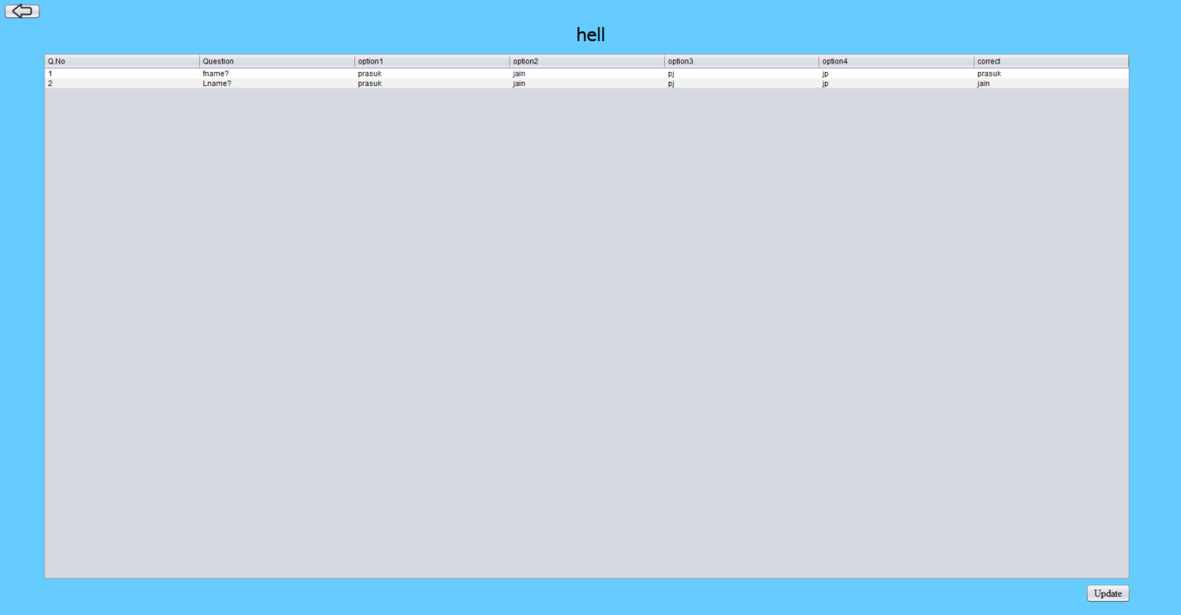

for(int r=0;r<size;r++)

{

for(int c=0;c<7;c++)

{

String value = table1.getModel().getValueAt(r, c).toString();

if(!value.equals(tab[r][c])) {

tab[r][c] = value;

try{

Class.forName("com.mysql.jdbc.Driver");

con = DriverManager.getConnection("jdbc:mysql://192.168.43.109:3306/test","root","root");

st = con.createStatement();

String query = "UPDATE `"+subject+"`.`"+testname+"` SET `Q_No`='"+table1.getModel().getValueAt(r, 0).toString()+"',"+

"`Question`='"+table1.getModel().getValueAt(r, 1).toString()+"',"+

"`option1`='"+table1.getModel().getValueAt(r, 2).toString()+"',"+

"`option2`='"+table1.getModel().getValueAt(r, 3).toString()+"',"+

"`option3`='"+table1.getModel().getValueAt(r, 4).toString()+"',"+

"`option4`='"+table1.getModel().getValueAt(r, 5).toString()+"',"+

"`correct`='"+table1.getModel().getValueAt(r, 6).toString()+"'"+" WHERE `Q_No`='"+table1.getModel().getValueAt(r, 0).toString()+"'";

st.executeUpdate(query);

con.close();

if(online)

new ViewPreviousTest(username,subject,true).setVisible(true);

else

new ViewPreviousTest(username,subject,false).setVisible(true);

this.setVisible(false);

}

} } }

e. Teacher create new test

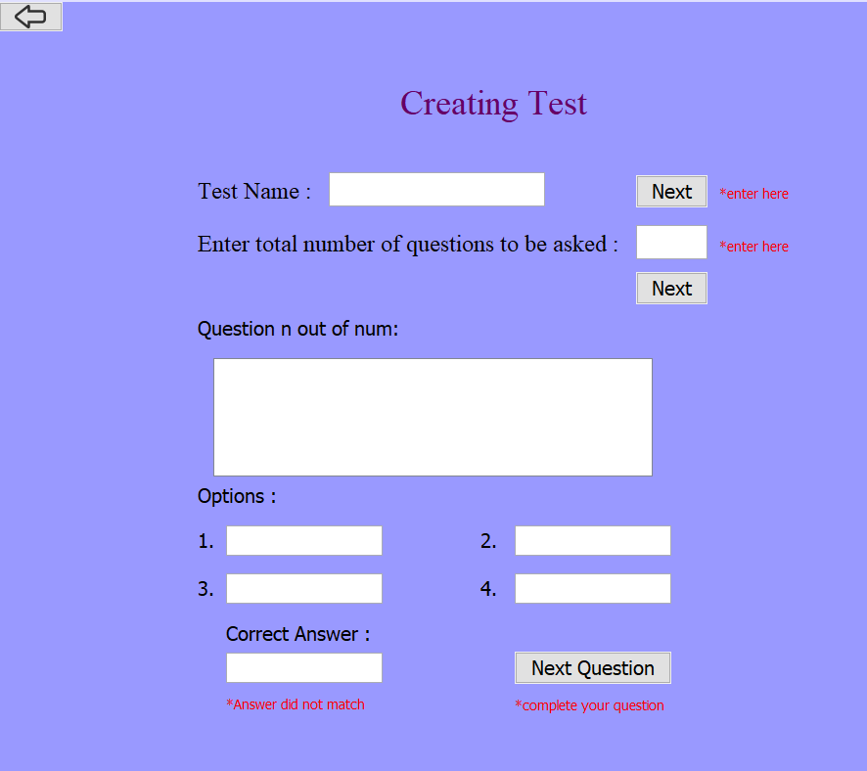

if(!(ques.trim().equals("") && op1.trim().equals("") && op2.trim().equals("") && op3.trim().equals("") && op4.trim().equals("") && corrAns.trim().equals("")))

{

if(corrAns.equalsIgnoreCase(op1) || corrAns.equalsIgnoreCase(op2) || corrAns.equalsIgnoreCase(op3) || corrAns.equalsIgnoreCase(op4)){

if(online){

query = "INSERT INTO `"+subject+"`.`"+testname+"`(`Q_No`,`Question`,`option1`,`option2`,`option3`,`option4`,`correct`) VALUES ( '"+n+"','"+ques+"','"+op1+"','"+op2+"','"+op3+"','"+op4+"','"+corrAns+"')";

}else{

query = "INSERT INTO `"+subject+"`.`"+testname+"`(`Q_No`,`Question`,`option1`,`option2`,`option3`,`option4`,`correct`) VALUES ( '"+n+"','"+ques+"','"+op1+"','"+op2+"','"+op3+"','"+op4+"','"+corrAns+"')";

}

int i = st.executeUpdate(query);

if(i>0) {

if(n==(num-1))

NextQuestion.setText("Create");

if(n==num) {

JFrame f = new JFrame();

JOptionPane.showMessageDialog(f, "Test Created");

try{

Class.forName("com.mysql.jdbc.Driver");

con = DriverManager.getConnection("jdbc:mysql://192.168.43.109:3306/studentresult","root","root");

st = con.createStatement();

if(online){

tablequery = "CREATE TABLE `studentresult`.`online_"+testname+"`"+

"( `rollNo` VARCHAR(15) NOT NULL ,"+

" `marks` INT NOT NULL ,"+

"`date` DATE NOT NULL , PRIMARY KEY (`rollNo`))";

}

else{

tablequery = "CREATE TABLE `studentresult`.`"+testname+"`"+

"( `rollNo` VARCHAR(15) NOT NULL ,"+

" `marks` INT NOT NULL ,"+

"`date` DATE NOT NULL , PRIMARY KEY (`rollNo`))";

}

st.executeUpdate(tablequery);

}

new Home(username,subject).setVisible(true);

this.setVisible(false);

}

else{

n++;

questionl.setText("Question "+n+" out of "+num+" :");

question.setText("");

option1.setText("");

option2.setText("");

option3.setText("");

option4.setText("");

correctans.setText("");}}

else{

JFrame f = new JFrame();

JOptionPane.showMessageDialog(f, "Question Insertion failed..."); } }

f. Student Enter password for online test

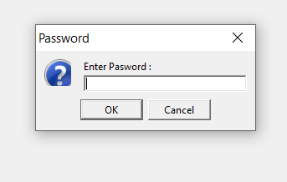

Class.forName("com.mysql.jdbc.Driver");

con = DriverManager.getConnection("jdbc:mysql://192.168.43.109:3306/test","root","root");

st = con.createStatement();

rs = st.executeQuery("SELECT password FROM `"+subject+"`.`online_test` WHERE `Test_Name`='"+testname+"'");

if(rs.next())

tablePass = rs.getString(1);

JFrame f = new JFrame();

testPass = JOptionPane.showInputDialog(f, "Enter Pasword :", "Password", JOptionPane.QUESTION_MESSAGE);

if(!testPass.equals(tablePass))

throw new IncorrectPassException("Wrong Password.!");

g. teacher view test password

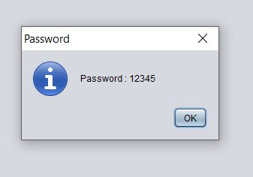

Class.forName("com.mysql.jdbc.Driver");

con = DriverManager.getConnection("jdbc:mysql://localhost:3306/test","root","root");

st = con.createStatement();

rs = st.executeQuery("SELECT password FROM `"+subject+"`.`online_test` WHERE `Test_Name`='"+testname+"'");

if(rs.next())

testPass = rs.getString(1);

con.close();

JFrame f = new JFrame();

JOptionPane.showMessageDialog(f, "Password : "+testPass, "Password", JOptionPane.INFORMATION_MESSAGE);

h. teacher change test password

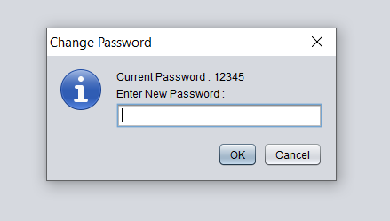

Class.forName("com.mysql.jdbc.Driver");

con = DriverManager.getConnection("jdbc:mysql://localhost:3306/test","root","root");

st = con.createStatement();

rs = st.executeQuery("SELECT password FROM `"+subject+"`.`online_test` WHERE `Test_Name`='"+testname+"'");

if(rs.next()){

testPass = rs.getString(1); }

JFrame f = new JFrame();

newPass = JOptionPane.showInputDialog(f, "Current Password : "+testPass+"\nEnter New Password :", "Change Password", JOptionPane.INFORMATION_MESSAGE);

if(newPass==null)

throw new ChgPassException("Cancel is pressed");

else if(newPass.trim().equals("")){

JOptionPane.showMessageDialog(f, "Enter Something");

throw new ChgPassException("Enter Something");}

st.executeUpdate("UPDATE `"+subject+"`.`online_test` SET `Test_Name`='"+testname+"',"+

"`Number_of_Questions`='"+table2.getModel().getValueAt(row, 1)+"',"+

" `password`='"+newPass+"' WHERE `Test_Name`='"+testname+"'");

JOptionPane.showMessageDialog(f, "Password Changed Successfully!","Success",JOptionPane.INFORMATION_MESSAGE);

con.close();

i. Student test page

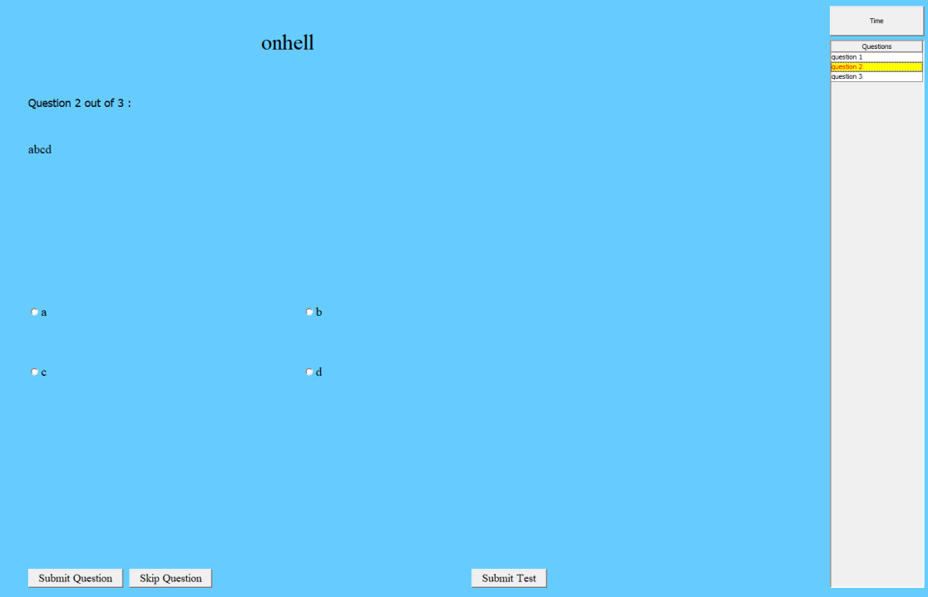

Class.forName("com.mysql.jdbc.Driver");

con = DriverManager.getConnection("jdbc:mysql://192.168.43.109:3306/"+subject+"","root","root");

st = con.createStatement();

String query = "SELECT * FROM `"+subject+"`.`"+testname+"` WHERE Q_No='"+qno+"'";

rs = st.executeQuery(query);

if(rs.next()){

q = rs.getString(2);

op1 = rs.getString(3);

op2 = rs.getString(4);

op3 = rs.getString(5);

op4 = rs.getString(6);

correct = rs.getString(7);

}

question.setText(q);

option1.setText(op1);

option2.setText(op2);

option3.setText(op3);

option4.setText(op4);

if(online)

rs = st.executeQuery("SELECT `Selected_Answer` FROM `studentresult`.`online_"+testname+"_"+rollNo+"` WHERE Question_No='"+qno+"'");

else

rs = st.executeQuery("SELECT `Selected_Answer` FROM `studentresult`.`"+testname+"_"+rollNo+"` WHERE Question_No='"+qno+"'");

if(rs.next()){

String answer = rs.getString(1);

if(answer.equals(op1))

option1.doClick();

else if(answer.equals(op2))

option2.doClick();

else if(answer.equals(op3))

option3.doClick();

else if(answer.equals(op4))

option4.doClick();

for(JRadioButton btn : buttons){

btn.setEnabled(false); }

nextquestion.setEnabled(false);

skipquestion.setEnabled(false); }

else{

for(JRadioButton btn : buttons) {

btn.setEnabled(true); }

nextquestion.setEnabled(true);

skipquestion.setEnabled(true);

}

con.close();

j. Teacher Profile

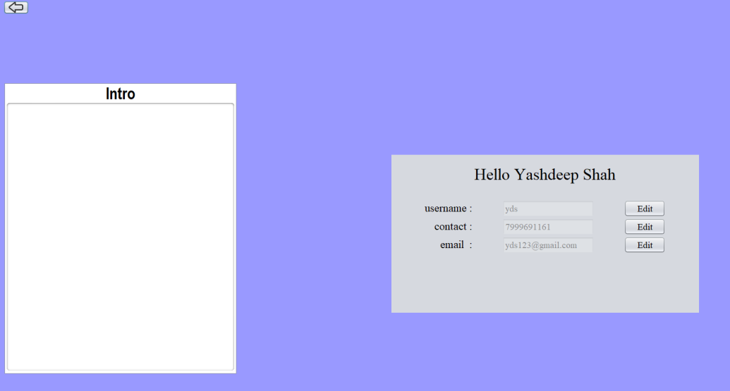

Class.forName("com.mysql.jdbc.Driver");

con = DriverManager.getConnection("jdbc:mysql://192.168.43.109:3306/test", "root", "root");

st = con.createStatement();

String query = "Select * FROM `test`.`createtable` WHERE username='"+username+"'";

rs = st.executeQuery(query);

if(rs.next()){

name = rs.getString(2);

hellouser.setText("Hello "+name);

editusername.setText(username);

editusername.setEnabled(false);

contact = rs.getString(6);

editcontact.setText(contact);

editcontact.setEnabled(false);

email = rs.getString(4);

editemail.setText(email);

editemail.setEnabled(false);

password = rs.getString(3);

gender = rs.getString(7);

}

k. Student Profile

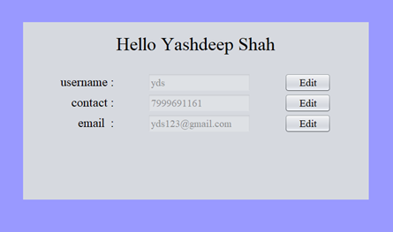

Class.forName("com.mysql.jdbc.Driver");

con = DriverManager.getConnection("jdbc:mysql://192.168.43.109:3306/test", "root", "root");

st = con.createStatement();

String query = "Select * FROM `test`.`createtable` WHERE username='"+username+"'";

rs = st.executeQuery(query);

if(rs.next()){

name = rs.getString(2);

hellouser.setText("Hello "+name);

editusername.setText(username);

editusername.setEnabled(false);

contact = rs.getString(6);

editcontact.setText(contact);

editcontact.setEnabled(false);

email = rs.getString(4);

editemail.setText(email);

editemail.setEnabled(false);

password = rs.getString(3);

gender = rs.getString(7);

}

l. Teacher test list for result

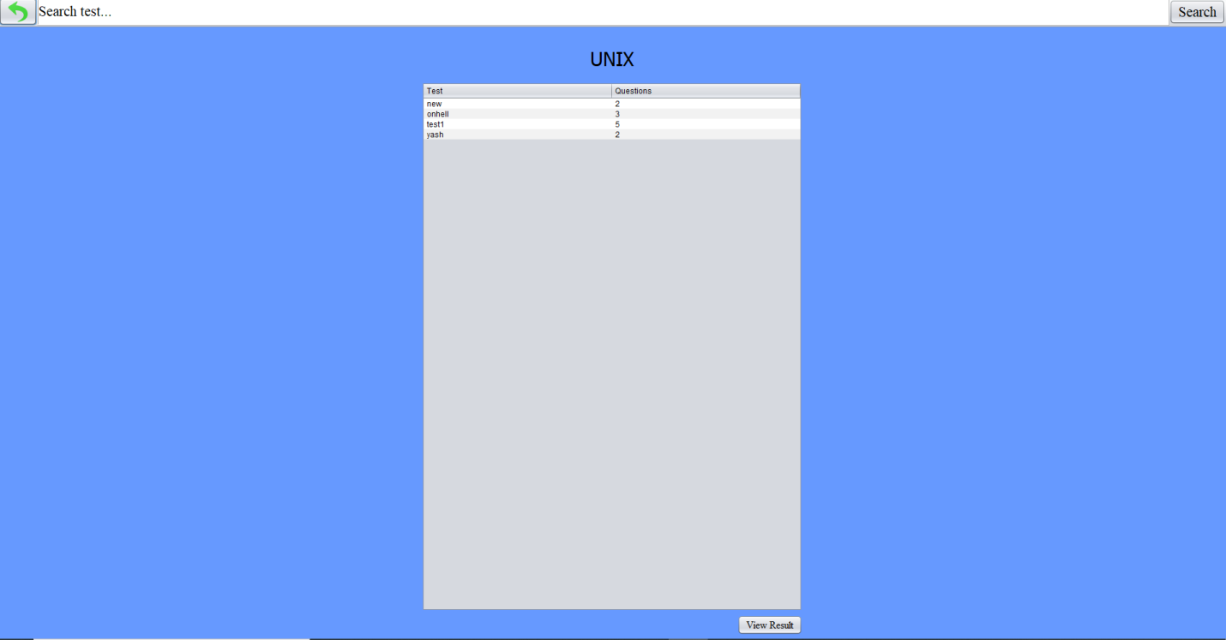

try{

int row = table2.getSelectedRow();

testname = table2.getModel().getValueAt(row, 0).toString();

new ResultTest(testname,username,subject,true,true).setVisible(true);

this.setVisible(false);

}

catch(ArrayIndexOutOfBoundsException e) {

JFrame f = new JFrame();

JOptionPane.showMessageDialog(f, "Select a Test First","Error",JOptionPane.ERROR_MESSAGE);

}

m. Teacher result table for test

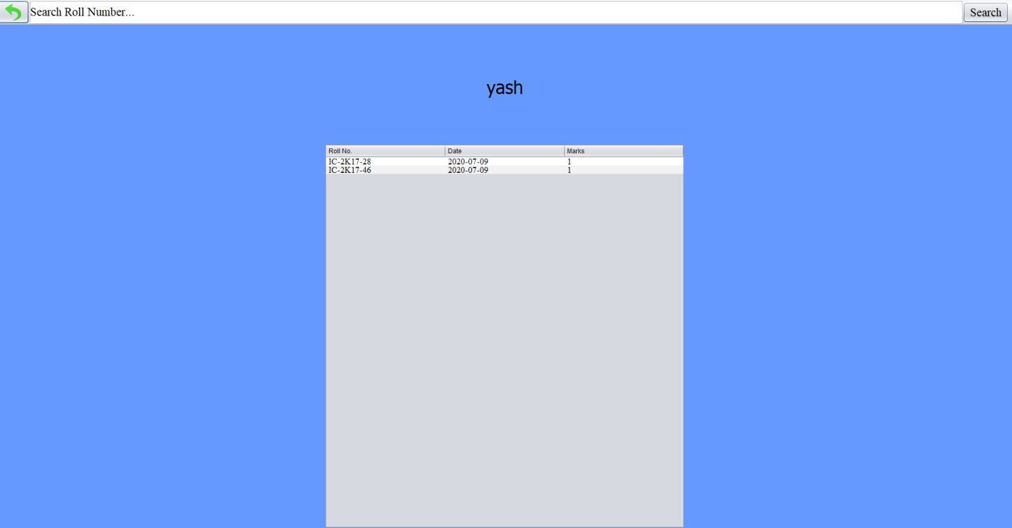

Class.forName("com.mysql.jdbc.Driver");

con = DriverManager.getConnection("jdbc:mysql://localhost:3306/studentresult","root","root");

st = con.createStatement();

query = "SELECT * FROM `online_"+testname+"`";

rs = st.executeQuery(query);

User user;

while(rs.next()){

user = new User(rs.getString("rollNo"),rs.getString("date"),rs.getInt("marks"));

test.add(user);

}

con.close();

for(int i=0;i<list.size();i++){

row[0]=list.get(i).getRollNo();

row[1]=list.get(i).getDate();

row[2]=list.get(i).getMarks();

model.addRow(row);

}

for(int r=0;r<size;r++){

for(int c=0;c<3;c++){

tab[r][c] = resulttb.getModel().getValueAt(r, c).toString();

}}

**System Requirements**

A server machine hosting the whole software.

Computers connected on a local area network along with the server with specifications:

|  |  |  |
| --- | --- | --- |
| * Processor Requirement | at least | Intel i3 |
| * RAM Requirement |  | 4 GB |
| * System Type |  | 32- bit |
| (minimum) |  |  |

**Future plans**

We had tried our best in making our project awesome in software version. Apart from this we are looking for many other suggestions in future enhancement for our project.

1. We are willing to add some more features:
2. Attendance system
3. Remainder system for personal and global worth
4. We will add a feature for student that they can practice tests from their home as well.
5. We are willing to release an application of our project in future.

**Conclusion**

The features of our software would help eliminate the traditional test system and instead of using paper registers one might just use our simple test system with our software. Our software supports the idea of “Digital India”. It would provide a digital platform to both the teachers and students and promote an active interaction between them. The software has been made using Java Swing, Java & MySQL. Being a software, it would be able to run across any device connected to the server via a network either a wired or wireless.

**Bibliography**

1. **Youtube-** <http://www.youtube.com/>
2. **GeeksforGeeks-** <http://www.geeksforgeeks.com/>
3. **Stackoverflow-** <http://www.stackoverflow.com/>
4. **Tutorials point-** <https://www.tutorialspoint.com/>
5. **Slide share-** <https://www.slideshare.net/>
6. **Google-** <https://www.google.com/>

**Appendices**

1. **JAVA Complete Reference**
2. **Practical JAVA programming**
3. **Practical Advance JAVA**
4. **Practical MySQL**
5. **Programmer’s guide to java (by Khalid A. Mughal)**